**2022 Sino-Swiss JMCM**

November 25, SUES and FHGR held a video conference for the 2022 Sino-Swiss Joint Management Committee. President Yu Tao, Vice President Xia Chunming, Wang Qin, Director of International Cooperation and Exchange, Zheng Shubin, Dean of Higher Vocational and Technical College, Xiao Qian, Deputy dean of Higher Vocational and Technical College, FHGR President Jurg Kessler, Andreas Deuber, Director of International Cooperation, Patric Arn, Head of Institute for Tourism and Leisure and other Management committee members attended the meeting. The meeting was presided over by Vice President Xia Chunming.

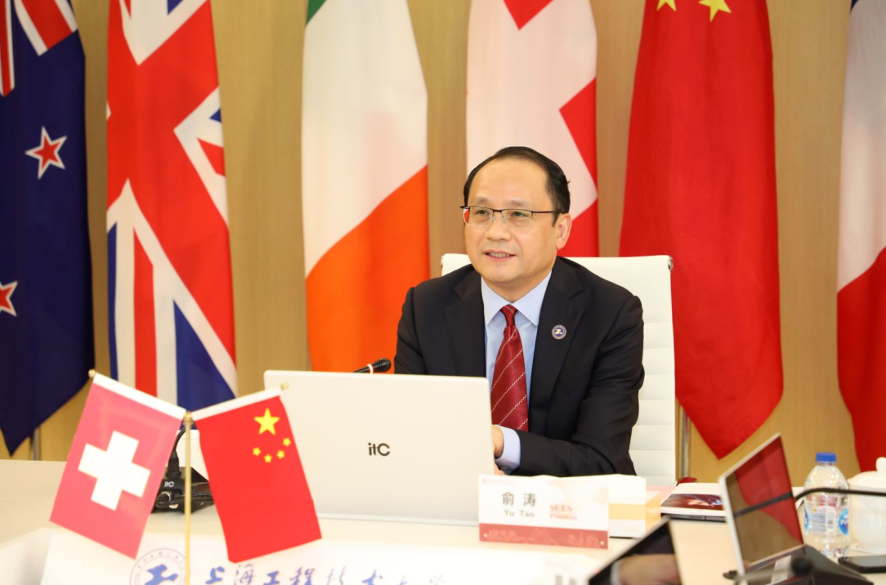

President Yu and President Kessler expressed cordial greetings to the members of the Management Committee and colleagues of both sides. President Yu first congratulated FHGR entry into the Swiss 2030+ Project, President Kessler on his election to the Board of Directors of the Confederation of Swiss University Presidents on behalf of the University of Applied Sciences, and FHGR on launching the construction of the new campus after a referendum vote next spring. President Yu said that with the joint efforts of both sides, the two universities completed the signing of a new round of 3-year cooperation agreement and successfully passed the evaluation of Sino-foreign cooperation in universities schools in Shanghai. He expressed the hope that through the cooperation between the two universities, more opportunities will be created for the education and exchange of the students of China and Switzerland, and it will become a model of friendly cooperation in education between the two countries.

President Kessler reviewed the history of the Sino-Swiss cooperative education program. Over the past decade, the two universities have deepened mutual understanding and trust in cooperation, maintained communication, exchanges and friendly consultations, and worked hard towards the common goals of both sides. President Kessler expressed his great hope that the two sides could meet offline next year to celebrate the ten years of successful cooperation on the 10th anniversary of the Sino-Swiss program.

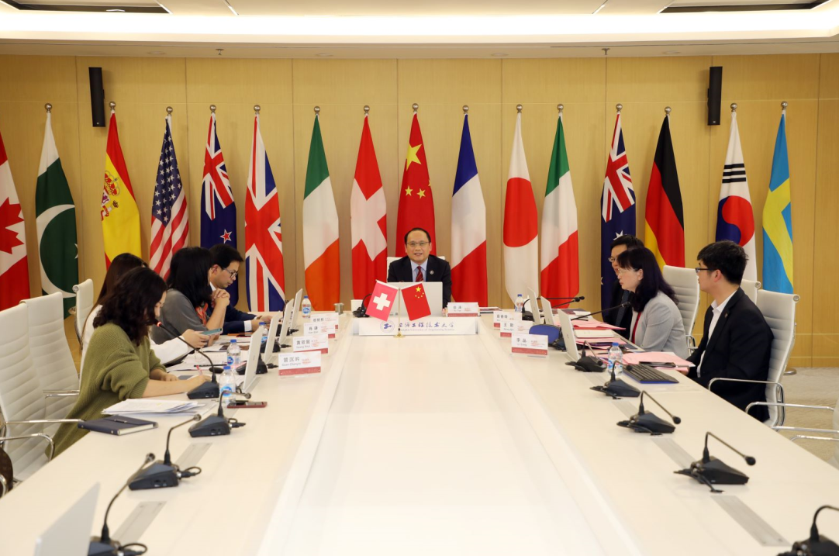

Prof. Zheng Shubin, Mr. Patric Arn and Ms. Thuc Lan Tran introduced the 2022 Sino-Swiss cooperation project in detail from the aspects of student, financial budget, curriculum, teacher exchanges, teaching quality management and so on, and reached a number of consensus. Ms. Xiao Qian made a report on the recent international exchange and cooperation activities between China and Switzerland.

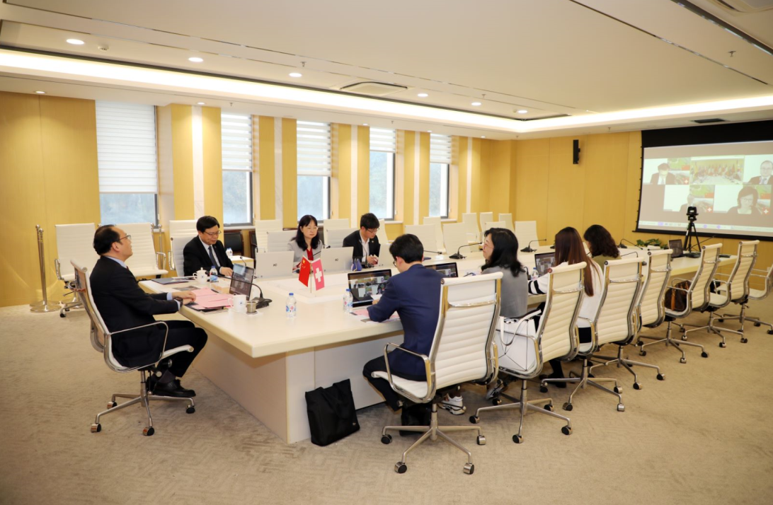

Finally, both sides indicated that they would take the 10th anniversary of China-Switzerland cooperative education program as an opportunity to further promote the pragmatic cooperation in a wider range of fields and push the cooperation between the two universities to a new level.

Report and photo by：

Management Department—Xinyi Huang